Website Post & Calendar Messaging

Sample Website Image (use Facebook graphic):
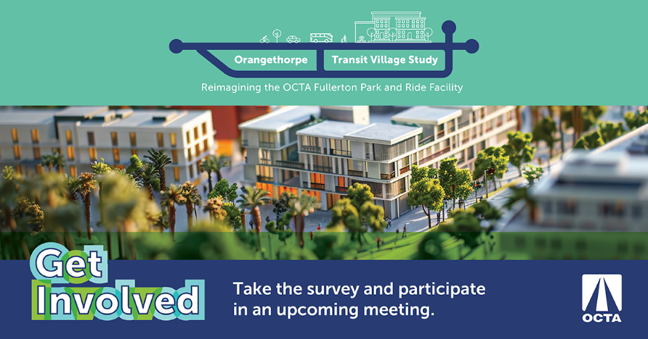

Join OCTA in-person on Saturday, October 19th from 10am-Noon, virtually on Tuesday, October 22nd from 6-7 pm, or Thursday, October 24th from 6-8 pm to learn and provide your thoughts on conceptual development ideas at the Fullerton Park and Ride. Can’t make it? Provide your input by completing the community survey by November 10th and enter for a chance to win one of two $50 gift cards. Participate now and receive project updates and future meeting invitations. Learn more about the plan by visiting octa.net/FullertonPnR.

CALENDAR DATE:
In- Person Community Meeting #1 | October 19th at 10 am
Orangethorpe Elementary School (Multi-Purpose Room) – 1400 S Brookhurst Rd, Fullerton, CA 92833

Virtual Community Meeting #2 | October 22nd at 6 pm (Register)

In- Person Community Meeting #3 | October 24th at 6 pm
Buena Park High School (Cafeteria) – 8833 Academy Dr, Buena Park, CA 90621

