Eblast/Newspaper Article & Nextdoor/Neighborhood Blog/Nixel Messaging

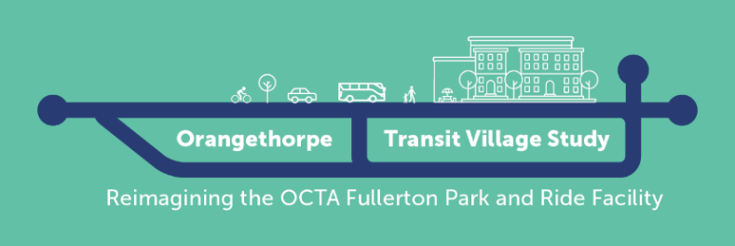
Sample Header:
For use any time before Oct 19th

Title: Help OCTA envision the future of the Fullerton Park and Ride!

Body:
The Orange County Transportation Authority (OCTA), in partnership with the City of Fullerton, is leading the Orangethorpe Transit Village Conceptual Study to explore potential development ideas for the Fullerton Park and Ride Facility. These ideas could include options for neighborhood shops, offices, and housing, amongst others. Be part of the planning process by providing your input at a community meeting or by taking an online survey!

Here is how to get involved:

Attend an In-Person Meeting:
Saturday, October 19th at 10 am
Orangethorpe Elementary School – Multipurpose Room
1400 S Brookhurst Rd, Fullerton, CA 92833

Thursday, October 24th at 6 pm
Buena Park High School – Cafeteria
8833 Academy Dr, Buena Park, CA 90621

The presentation will be 15 minutes after the event begins.
Refreshments and children’s activities will be provided.

Attend the Virtual Community Webinar”
Tuesday, October 22nd at 6 pm
Webinar ID: 818 5873 6568
Call-In: +1 (213) 338-8477
Register here!

Spanish Call In-Line: +1 (224) 501-3412
Access Code: 123-283-077

Korean Call In-Line: +1 (872) 240-3311
Access code: 630-951-133
Participate in the Online Survey
Take the survey by November 10th for a chance to win one of two $50 gift cards!

Learn more about the plan and how you can get involved by visiting octa.net/FullertonPnR.

