Website Post & Calendar Messaging
Sample Website Image (use Facebook graphic):

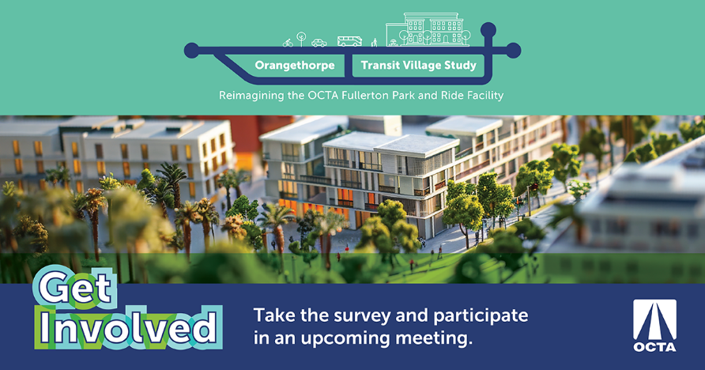
OCTA heard your feedback! In the first community survey conducted in Fall 2024, you provided valuable insights on your riding habits, preferred transit-supportive features, and facility improvements at the Fullerton Park and Ride.

Join OCTA again online on Thursday, March 20 at 6PM and in-person Wednesday, March 26 at 6PM to receive an update on the Study and provide your thoughts on conceptual development ideas.
Can’t make it? Complete the community survey by April 7th and enter for a chance to win one of two $50 gift cards. Participate now and receive project updates and future meeting invitations. Learn more about the plan by visiting octa.net/FullertonPnR.

CALENDAR DATE:

Virtual Community Meeting #1| Thursday, March 20 at 6PM (Register)

In- Person Community Meeting #2 | Wednesday, March 26 at 6PM
Fullerton Community Center – Classroom 1A | 340 W Commonwealth Ave., Fullerton, CA 92832

